SACRAMENTO SPLITTAIL

Pogonichthys macrolepidotus (Ayres)

Status: Class 2. Species of Special Concern. While the splittail was delisted as a threatened species because of the demonstrated resiliency of its population, it is presently in decline. Its abundance could quickly change due to the rapid changes in the San Francisco Estuary expected to occur as a result of multiple factors. In particular, the poorly studied but genetically distinct population(s) in the lower estuary are of concern because of their small size and apparent vulnerability to change.

Description: Splittail are large cyprinids, growing in excess of 40 cm SL, and are distinctive in having the upper lobe of the caudal fin larger than the lower lobe. The body shape is elongate with a blunt head. Small barbels may be present on either side of the subterminal mouth. Splittail possess 14-18 gill rakers, and their pharyngeal teeth are hooked and have narrow grinding surfaces. Dorsal rays number 9-10, pectoral rays 16-19, pelvic rays 8-9, and anal rays 7-9. The lateral line usually has 60-62 scales, but ranges from 57 to 64. The fish are silver on the sides and dusky grey dorsally. Adults develop a slight hump behind the head (nuchal hump). During the breeding season, the caudal, pectoral, and pelvic fins take on a red-orange hue and males develop small white nuptial tubercles in the head region.

Taxonomic Relationships: Splittail were described in 1854 by W. O. Ayres as Leuciscus macrolepidotus and by S. F. Baird and C. Girard as Pogonichthys inaeqilobus. Ayres' species description came out first so was accepted as the official description although Pogonichthys became the genus name because of its striking differences from other cyprinids (Hopkirk 1973). The genus Pogonichthys comprises two species, P. ciscoides (Hopkirk 1973) and P. macrolepidotus. The former species was endemic to Clear Lake, Lake County, and became extinct in the early 1970s. Baerwald et al. (2006) showed that there are two genetically distinct populations of Sacramento splittail, one centered in San Pablo Bay around the Petaluma and Napa rivers in the lower San Francisco Estuary and the other centered around the Delta and Suisun Marsh. Analysis of otoliths microchemistry validates that the two populations maintain themselves in the different habitats (Feyrer et al. 2007). The two populations would qualify as Distinct Population Segments (San Pablo DPS and Delta DPS) if listed under the federal Endangered Species Act of 1973. The genetic relationships of splittail from San Francisco Bay tributaries (primarily Walnut Creek and Alemeda Creek) are unknown.

Life History: The life history of splittail is reviewed in Moyle (2002), Moyle et al. (2004) and Sommer et al. (2007). Spittail depend both on brackish-water rearing habitats in the San Francisco Estuary and on floodplain spawning habitats immediately above the estuary. They migrate between the two habitats on a near-annual basis. Historically, there were non-estuarine dependent populations, especially in the southern Central Valley (e.g. Lake Tulare) but these populations are gone. The basic life history pattern for the Delta/Suisun Marsh population today is this: (1) from November through February adults migrate upstream in pulses in response to flow events; (2) adults spawn on floodplains or flooded edge habitat in March and April and then migrate back downstream; (3) embryos and larvae remain in the flooded vegetation for 3-6 weeks, during March and April (Crain et al. 2004); (4) in April and May, as flood water recedes, juveniles leave the flooded areas and move downstream; and (5) juveniles rear in estuarine marshes for 1-2 years before spawning for the first time. The success of this life cycle depends on extended, large scale floodplain inundation (e.g., in the Yolo Bypass or lower Cosumnes River), although some spawning is successful even in non-flood years (Moyle et al. 2004). The pattern may be somewhat different for the Petaluma/Napa populations because adults can spawn in brackish water (to 5 ppt salinity) and juveniles can rear in water up to 14 ppt (Feyrer, Hobbs, and Sommer, unpublished ms.).
Splittail are relatively long-lived (7-10 years) and are highly fecund (up to 150,000 eggs per female). Their populations fluctuate on an annual basis depending on spawning success and strength of the year class (Daniels and Moyle 1983, Sommer et al. 1997). Both male and female splittail mature by the end of their second year, although occasionally males may mature by the end of their first year and females by the end of their third year. Fish are about 180-200 mm SL when they attain sexual maturity (Daniels and Moyle 1983). There is some variability in the reproductive period, with older fish reproducing first, followed by younger fish which tend to reproduce later in the season (Moyle et al. 2004). Generally, gonadal development is initiated by fall, with a concomitant decrease in somatic growth (Daniels and Moyle 1983).
Splittail spawn on submerged annual vegetation in flooded areas or along the edges of rising rivers; the most important known areas are the Yolo and Sutter bypasses and the Cosumnes River floodplain, but ripe splittail have been found in areas as diverse as the Petaluma River, Suisun Marsh, the Sacramento River, and the lower Tuolumne River. The fertilized embryos stick to the plants and the larvae remain in and among the plants for the first few days of life. Sommer et al. (2008) observed that post-larval splittail (ca. 21 mm FL) sought out shallow areas with emergent and submerged vegetation during the day but moved into deeper water at night, among tules and submerged aquatic plants. Larger fish used deeper water more consistently, both day and night. Fish of all sizes exhibited schooling behavior.
Splittail are benthic foragers that feed mostly on aquatic invertebrates although detrital material can make up a high percentage of their stomach contents by volume. Juvenile splittail feed on small benthic invertebrates, most consistently chironomid midge larvae, but diet varies considerably with locality (Feyrer et al. 2007). Adults feed opportunistically on earthworms, clams, insect larvae, and other invertebrates. Historically, splittail fed extensively on opossum shrimp (Neomysis mercedis) but their diet shifted with the collapse of shrimp population following invasion of the overbite clam (Corbula amurensis) (Feyrer et al. 2003). The shift was towards feeding on the clams themselves, as well as on other benthic invertebrates.
Splittail are preyed upon by striped bass and other predatory fishes, as well as by aquatic birds. A preference for splittail as prey by striped bass has long been recognized by anglers, who fish for splittail in order to use them as bait.

Habitat Requirements: Splittail are adapted for estuarine life so, they are tolerant of a wide range of salinities (0-29 ppt) and temperatures (5-33°C). This is demonstrated by their presence year round in Suisun Marsh and the Petaluma River estuary, generally in sloughs < 4 m deep, where summer salinities are typically 6-10 ppt and temperatures 15-23°C. Adults are more tolerant of high temperatures and salinities than juveniles so optimal conditions are generally where salinities are low (<10 ppt) and temperatures cool (<20°C). They are remarkably tolerant of low dissolved oxygen and can be found for at least short periods in water where levels are around 1 mg O² L⁻¹ (Young and Cech 1996, Moyle et al. 2004).
Splittail require a rising hydrograph for upstream migration and flooded vegetation for spawning and as rearing areas for the early life history stages. Large flooded areas need to be at least 1 m deep, with some deeper areas as refuges from predation for adults during the day. Both adults and juveniles leave the floodplain as water levels drop and temperatures rise to 15-20°C (Moyle et al. 2007). Young-of-year and yearling splittail are common in beach seine sampling along the Sacramento River between Rio Vista and Chipps Island (R. Baxter, CDFG, pers. comm.). Furthermore, in CDFG Bay Study samples, splittail are most common from stations <20 ft deep. Thus, juvenile splittail appear to concentrate in the shallow edges of the Sacramento River as they move downstream to rearing areas. In the lower Napa River watershed splittail juveniles have been documented using the shallow water habitats in recently restored tidal marsh (Stillwater Sciences 2006).

Distribution: The Sacramento splittail is a California Central Valley endemic that was once distributed in lakes and rivers throughout the Central Valley. Historically, they were found as far north as Redding by Rutter (1908), who collected them below Battle Creek Fish Hatchery in Shasta County. Splittail are no longer found in this area and are limited by the Red Bluff Diversion Dam in Tehama County to the downstream reaches of the Sacramento River. They also enter the lower reaches of the Feather River on occasion, but records indicate that Rutter (1908) had collected them as far upstream as Oroville. Splittail are also known from the American River and have been collected at the Highway 160 bridge in Sacramento, although in the past Rutter (1908) collected them as far upstream as Folsom. He also collected them from the Merced River at Livingston and from the San Joaquin River at Fort Miller (where Friant Dam is today). They were once abundant in Tulare Lake, and in other waters of the San Joaquin Valley (Moyle et al. 2004). Snyder (1905) reported catches of splittail from southern San Francisco Bay and at the mouth of Coyote Creek in Santa Clara County, but recent surveys are inconclusive as to whether a reproductive population of splittail continues to exist in the South Bay; Leidy (2007) notes records only from 1983 and 2000. Evidence of a persistent population is more convincing in lower Walnut Creek, Contra Costa County, where a 1998 CDFG gill-net survey of the tidal reaches of the creek found splittail to be the most abundant of fish (Leidy 2007). Sacramento splittail have also been recorded from the estuarine environments of Peyton and Hastings Sloughs, near to the mouth of Walnut Creek and in Grayson Creek, just above its confluence with lower Walnut Creek (Leidy, 2007).
Splittail are now largely confined to the Delta, Suisun Bay, Suisun Marsh, Napa River, Petaluma River, and other parts of the San Francisco Estuary, while spawning on upstream floodplains (Moyle et al. 2004). The consistent presence of young-of-year splittail in the Sacramento River over 200 km upstream of the Delta may indicate that a small population persists there, although their presence may also indicate that some adults make long migrations to find suitable spawning areas, especially in dry years (Feyrer et al. 2005). In the Delta, they are most abundant in the north and west portions, although other areas may be used for spawning. Non-spawning fish are found in Suisun Bay and Suisan Marsh and the Petaluma and Napa marshes. Adults from both DPS’s were found to forage in the open water of Suisan Bay but Suisun Marsh was almost exclusively used by adults from the Delta DPS, and the San Pablo population was far more abundant in western Suisun Bay. This suggests that San Pablo DPS fish preferentially forage in Petaluma and Napa marshes, closer to their natal watersheds (Baerwald et al. 2008). In wet years, splittail have been found in the San Joaquin River below its confluence with the Merced River and in the lower Tuolumne River and there may be spawning on a fairly regular basis in the lower San Joaquin River. Occasionally, splittail are caught in San Luis Reservoir which stores water that has been pumped from the Delta (Moyle et al. 2004).

Trends in Abundance: Splittail were once abundant enough so that they were harvested by Native Americans and by commercial fisheries in the 19th and early 20th centuries. Jordon (1884), for example recorded them as “very common in the Sacramento and … brought in considerable numbers to the San Francisco Market (p. 617).” Their overall abundance and range apparently shrunk with the development of California’s water system (e.g., the elimination of Lake Tulare) but they remained a common fish in the Delta (Turner and Kelly 1962).
There are currently seven sampling programs that monitor splittail abundance along with other fishes in the estuary (Moyle et al. 2004). The programs are (1) CDFG Summer Townet Survey (started in 1959), (2) CDFG Fall Midwater Trawl Survey (1967), (3) USFWS Chipps Island trawl survey (1975), (4) U. C. Davis Suisun Marsh trawling and seining surveys (1980), (5) USFWS Beach Seine Survey (1979), (6) CDFG San Francisco Bay trawling survey (1980), and (7) fish salvage operations at Central Valley Project (CVP) and State Water Project (SWP) pumps in the south Delta (1979). None of these surveys or the indices calculated from them were designed specifically for splittail so the results of each have to be interpreted with caution, although they have all been used in analyses of splittail population trends (Moyle et al. 2004). According to Moyle et al. (2004): “Combined, the surveys indicate that (1) splittail populations have high natural variability, a reflection of their life history strategy, (2) some successful reproduction takes place every year, and (3) the largest numbers of young are produced only during years of relatively high outflow. These findings suggest that the majority of adult fish in the population result from spawning in wet years and lowest numbers are produced during drought years (p. 13)”. Essentially, no consistent trends were detected from 1962 through 2002.
When numbers are compared from 1980-2008 between the two programs that catch the most splittail, the results are similar. The fish salvage operations essentially capture migrating adults and juveniles during January through April (Figure 1), while the Suisun Marsh program captures resident fish all year around (Figure 2). Both show a peak in abundance in 1980, presumably the result of a series of wet years, followed by a decline through the 1990s, reflecting an eight-year drought. USFWS (2003) indicated that there was some evidence of decline in splittail numbers but the species was not in danger of declining to extinction. Since then numbers have fluctuated but have presumably been far below the numbers present in the 1980s and probably earlier. The model of population dynamics presented in Moyle et al. (2004) indicates high resiliency in splittail populations, suggesting they can recover from very low levels quickly. However, the continued decline in abundance shown in the pumping plants suggests that the portion of the population that exists in the southern part of the Delta may be in serious trouble (Figure 1) while the more northern part of the population, reflected in the Suisun Marsh data, appears to have a less severe decline in recent years (Figure 2). Seining surveys at boat ramps around the Delta and lower rivers, which capture mainly young-of-year fish, show high variability in numbers and no real trends; the catches seem to primarily reflect annual spawning success near the seining areas.
Trends for the genetically distinct population(s) in the lower San Francisco Estuary are not known, but it is likely they are much smaller than the Delta populations.

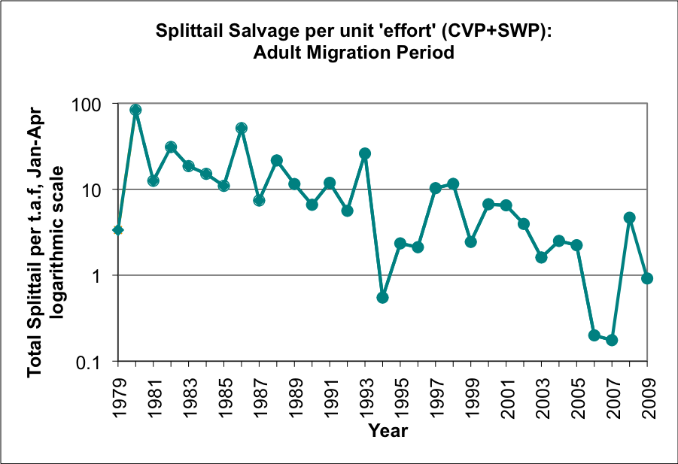
Figure 1. Number of splittail captured per thousand acre feet of water in the pumps of the South Delta, January-April, 1979-2009. Note the logarithmic scale on the Y vertical axis. Graph courtesy of David Wright, California Department of Fish and Game.

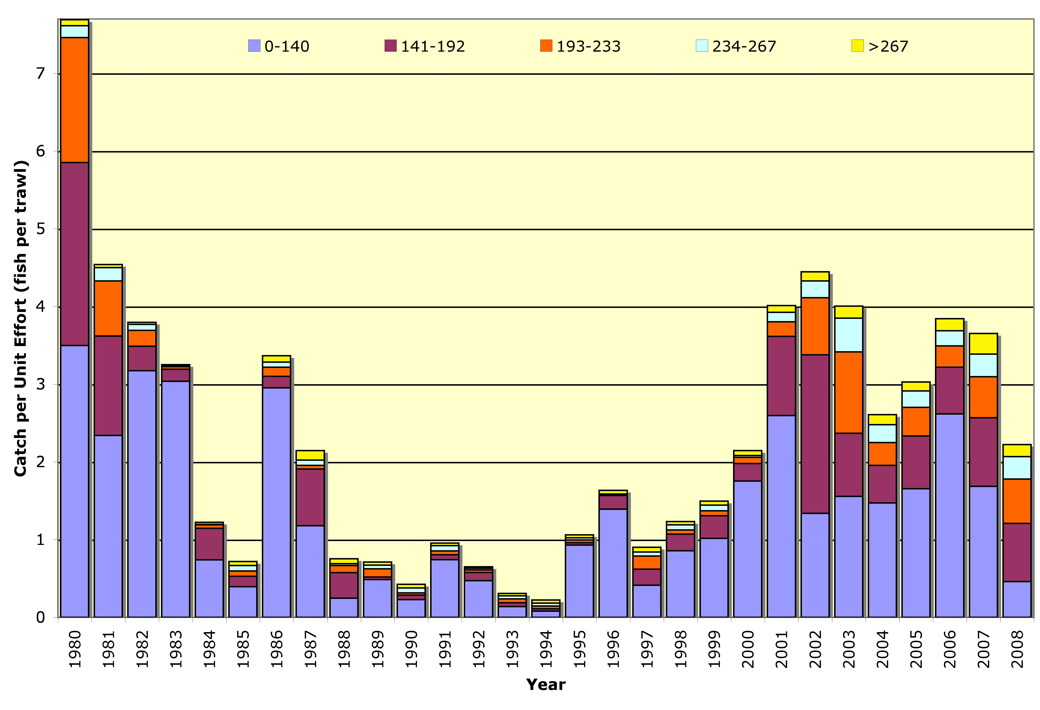
Figure 2. Annual catch per effort of splittail of different size classes in Suisun Marsh 1980-2008. Each bar represents 150-200 trawls. The bottom-most section of each bar represents catches of young of year. Graph by Teejay Orear, UC Davis.

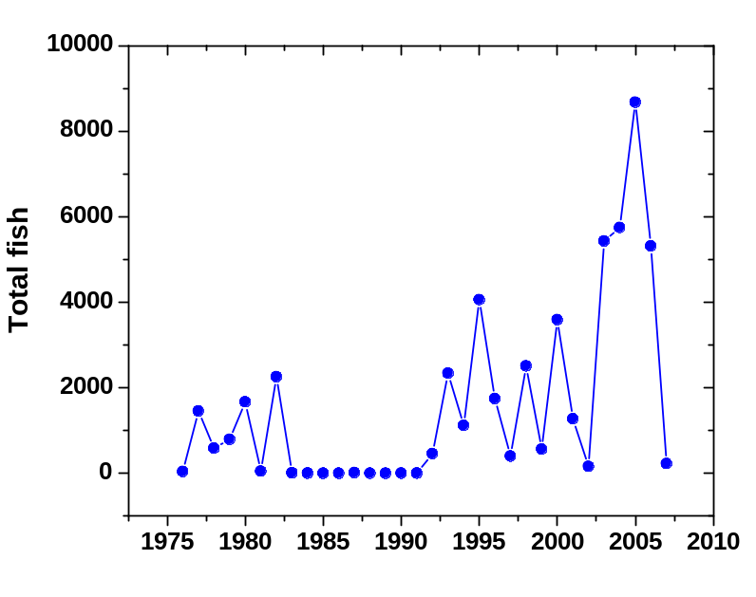
Figure 3. Splittail catch from USFWS Beach Seine Survey. Points are total annual catch over 20 stations consistently sampled each year from 1976-2007. Total catch is weighted by the number of months sampled each year especially in mid-80s to mid 90s. Values over past decade are not influenced by the weighting, i.e. 11-12 months were sampled
in each year. Graph by W. A Bennett.
Nature and Degree of Threats: The splittail is a resilient species (Sommer et al. 1997, Moyle et al. 2004) but it lives in a rapidly changing environment that is increasingly modified for human use (Table 1). Its present status may just be a shelf in a long term decline. Between the start of the massive influx of non-native peoples into California in the 1850s and the completion of Oroville Dam in 1962 (the final big dam in Central California), the range and total abundance of splittail declined. The splittail is now largely confined to the Sacramento-San Joaquin estuary, the floodplains upstream, and channels between islands. Its populations are highly dependent on artificially maintained flows and floodplains. This means that its long-term survival depends upon favorable conditions in the estuary and upon having adequate spawning habitat, as well as access to it. The potential threats to splittail are, in approximate order of importance: (1) changed estuarine dynamics in relation to water project operations, (2) alteration of rearing habitat, (3) modification of floodplains (spawning habitat), (4) pollution from agricultural and urban sources, (5) alien species, and (6) exploitation.

 | Rating | Explanation
Major dams | High | All waters are regulated by dams one way or another
Agriculture | High | Toxic run-off and channel modification can affect splittail; entrainment in major diversions.
Grazing | N/A | Included as part of agriculture
Rural residential | Low | Residences on the edges of Petaluma, Napa, and Suisun marshes could have localized effects.
Urbanization | Intermediate | All habitat is on urban fringes; sewage; water diversion and entrainment
Instream mining | n/a
Mining | Low | Legacy effects of gold mining, e.g. mercury
Transportation | Intermediate | Migratory corridors etc. lined with roads and railroads, which also cross Suisun Marsh
Estuarine alteration | High | San Francisco Estuary continues to change rapidly
Logging | N/A
Fire | N/A
Recreation | Low | Recreational boating etc. may affect habitat
Harvest | Low | Some harvest for bait and of migrating adults for food
Hatcheries | N/A
Alien species | High | Invaders change food supply; effects of new invaders unpredictable.
Table 1. Major anthropogenic factors limiting, or potentially limiting, viability of populations of splittail in California, where a factor rated “high” is a major limiting factor (or potential limiting factor), a factor rated “intermediate” is a factor that has the potential to be a major limiting factor but has had only a moderate effect so far on population viability, and a factor rated “low” has a low or unknown effect on population viability. Certainty of these judgments is high.

Major dams. Splittail depend on outflows from the Sacramento and San Joaquin rivers, and their major tributaries, for successful completion of their life cycles. These rivers are all highly regulated by dams. In the case of the San Joaquin River, major dams have pretty much eliminated splittail habitat above the mouth of the Merced River by shutting off flows completely. Likewise, the Tulare Basin no longer supports splittail because dams and downstream diversions take all the water from the rivers. It is not a coincidence that one of the few places where spawning can take place in most years is the re-created floodplain on the lower Cosumnes River, because the river is unregulated so some flooding can occur in most years (Moyle et al. 2007).
For the Sacramento River, spawning depends on releases from the large rim dams, usually for flood control, high flow events from small tributaries (e.g. Cache and Putah creeks), and occasional spills from the large dams. Strong year classes of splittail are created when the Yolo and Sutter bypasses and other floodplain areas are inundated for at least six weeks in late February and through April, provided depths are adequate and temperatures are <20°C. These conditions need to occur, at a minimum, every 3-4 years to maintain large adult populations. Historically, the separation of floodplains from their rivers in the 19th and early 20th centuries must have been devastating to splittail populations, especially along the San Joaquin River. Fortunately the creation of huge artificial floodways (Yolo and Sutter bypasses) in the 1920s and ‘30s that coincidentally created near-ideal conditions for splittail spawning and rearing and maintained their populations(Sommer et al. 2007). However, splittail numbers reached record lows in the estuary in 1994 after six years of drought greatly reduced the amount and frequency of flooding. Given the increasing demand for water and trends towards managing the Yolo and Sutter bypasses in ways that reduce or control flooding, there is no guarantee that these areas will continue to be consistently favorable to splittail spawning, although the creation of a new floodplain area along the Cosumnes River (Moyle et al. 2007) and proposals to do so elsewhere are positive signs.
Agriculture. All habitats used by splittail are heavily influenced by agriculture. Suisun Marsh has been diked and drained to create a combination of pasture for cows and marsh to raise wild ducks, as have the Napa and Petaluma marshes. The flows in rivers are regulated to provide water for agriculture. The bypasses and floodplains used for spawning are largely devoted to agriculture. Migrating fish are subject to entrainment in agricultural diversions, including the large pumps in the South Delta. The waters which splittail live are polluted with agricultural chemicals and some rivers (e.g. the lower San Joaquin River) are consequently unsuitable for splittail survival. Some contaminants, such as selenium from San Joaquin Valley agricultural drainage, can accumulate in splittail and potentially interfere with reproduction and change behavior. Thus, the long-term persistence of splittail depends on a positive interaction between agricultural practices and splittail populations.
While Feyrer et al. (2007) show that juvenile splittail are very flexible in their diet and habitat characteristics, they also note that some habitats are worse than others for the fish, reflected in reduced growth rates. Right now, splittail are thriving in the highly altered Suisun Marsh and Petaluma marshes, although growth rates are somewhat reduced following the change in food supply from the overbite clam invasion. In Suisun Marsh, periodic low dissolved oxygen ‘sags’ occur, from return water from duck clubs, laden with organic matter (R. E. Schroeter, unpublished data). Efforts are being made to reduce this problem but other changes to water quality could emerge, resulting from changed operations of the Salinity Control Gates or other factors.
Urbanization. The comments made above for agriculture also apply to urbanization and suburbanization, but urban sources of toxic substances is a constant worry. The San Francisco Estuary receives toxic contaminants from a variety of sources and their amount and composition varies tremendously with time. The effects of pesticides and other toxic substances from urban runoff on splittail are not known, but there is considerable potential for negative interactions (Sommer et al. 2007). Because splittail forage on the bottom, consuming large amounts of detritus, they may be particularly susceptible to contaminants that accumulate there or in benthic organisms. Selenium, from urban and agricultural sources is of particular concern because it accumulates in overbite clams, which splittail consume, and has been demonstrated to inhibit growth and reproduction in splittail and other fishes (Sommer et al. 2007). In addition, sewage outflows release micropollutants (hormones, etc.) that can affect splittail and other fish. Thus the proposed increase in tertiary treated sewage water flowing into the Marsh from Fairfield could affect splittail in a number of ways, both positive and negative.
Estuarine alteration. The upper San Francisco Estuary, home to splittail, is completely altered in structure and function; the Delta has become a collection of heavily farmed, subsided islands protected by inadequate levees, which force the water to flow through deep channels with little edge habitat (Lund et al. 2007; in press). Into this altered system, freshwater comes in from highly altered rivers with highly altered flow regimes. The San Joaquin River contributes minimal inflow and what water flows in is highly polluted with agricultural drainage and urban wastewater. The Sacramento River contributes more water in the summer (and less in winter) than it did historically but this water is moved across the Delta to the giant pumps of the State Water Project and the federal Central Valley Project, dramatically changing the normal seaward gradients of flow, salinity, and other factors that fish respond to. As Moyle and Bennett (2008) document, the Delta has increasingly become, from a fish perspective more like a freshwater lake than the upper part of an estuary. This lake-like habitat does not create conditions in which splittail thrive (Nobriga et al. 2005) but, fortunately, for now splittail only have to pass through it during times when the water is high and the Sacramento River outflow most often passes through floodplains. Likewise, the net flow is usually downstream in spring when the juvenile splittail are moving down to rearing areas, although this does not stop millions from being entrained in the CVP and SWP pumps in some years. It is apparent that in most years, splittail have only limited places to rear, Suisun Marsh and vicinity and Petaluma/Napa Marsh and vicinity, with a scattering of individuals elsewhere, such as the Sutter Bypass. So far, this has worked for splittail, enabling them to sustain what appear to be large populations (Moyle et al. 2004), although there are no real estimates of numbers.
However, the Estuary is changing. One change is the continuous increase in the amount of water being diverted both upstream of the Delta and from the Delta itself, although diversions from the south Delta have been reduced since 2007 to protect delta smelt and Chinook salmon. There are now immense pressures on the system to find ways to continue to remove more fresh water, including increasing upstream diversions. There is also a high probability that in a few years there will be large changes to the Delta and Suisun Marsh, as sea level rises and levees collapse. In the Delta, subsided islands will fill with water, probably salty, creating large areas of open water (Lund et al. 2007, Moyle 2008). In Suisun Marsh, the patchwork of freshwater marsh maintained by duck hunting clubs and wildlife areas will likely be converted into tidal and subtidal habitat. Right now, we do not know how these changes will affect splittail or other fishes in the Estuary, but the potential for a sudden decline is high.
Harvest. Although splittail have been harvested as food and bait by sport anglers, there is no evidence that this exploitation has contributed to their decline. However, an annual fishery concentrates on migrating spawners which could present a problem if harvest of large females become excessive (Sommer et al. 2007).
Alien species. Introduced species are a perpetual problem in the San Francisco estuary, especially those introduced from the ballast water of ships. The most recent problem introductions have been several species of planktonic copepods, Brazilian waterweed (Egeria densa) and the overbite clam. The copepods are important for food larval and juvenile splittail and a shift in species, especially towards the tiny and apparently inedible Limnoithona tetraspina is a cause for concern, although no effects have been detected. Changes in copepod abundance and composition are, at least in part, the result of the invasion by the overbite clam. This clam has become extremely abundant in Suisun Bay, from which it filters out much of the planktonic algae, the base of the food web that leads to splittail (Feyrer et al. 2003 The overbite clam has had much less of an impact on planktonic invertebrates in Suisun Marsh than it has elsewhere and this may be one reason the splittail is so abundant there. Adult splittail feed directly on the clams. From a broader perspective, alien species represent a threat to splittail because new species are constantly appearing in the estuary, some becoming very abundant, with unpredictable effects on native fishes.

Effects of Climate Change: From the perspective of splittail, climate change will have two major effects, increased variability in flooding and rise in sea level. An example of potential effects of increased variability in flooding can be seen in the period 1980-1995, a period which saw some of the most extreme conditions the estuary has experienced since the arrival of Europeans. The period 1986-1992 was one of continuous drought. Ironically, there were exceptionally high outflows at the beginning because of severe rain in February 1986. The prolonged drought had two major interacting effects: a natural decrease in outflow and an increase in the proportion of inflowing water being diverted. A natural decline in splittail numbers would be expected from the reduced outflow, because of the reduced availability of spawning and larval rearing habitat. The strong year class produced from the 1986 flooding was presumably an important factor in getting splittail through six years of drought, although some young of year were produced every year (Figure 2). It is important to recognize that extreme floods and droughts have occurred in the past and splittail have managed to persist through them. However, climate change will greatly increase the variability of flows, with bigger floods (probably good for splittail if the timing is right) but longer drought, with more extended periods of low flows. These extreme conditions will be made more severe by increased diversion of water both upstream and in the Delta. The net effect of all this is likely to be more extreme fluctuations in splittail populations, with the potential to reach numbers low enough to push the species towards extinction.
As sea level rises, large parts of Suisun and Petaluma marshes are likely to become inundated. These key rearing areas will probably be saltier for longer periods of time with food organism and predator populations changing in response. It is possible that flooded islands in the Delta or new tidal marsh habitat (e.g., Cache Slough region) will replace habitat lost elsewhere. Overall the rise of sea level has the potential to dramatically change splittail habitat, but whether this will be in a positive or negative way is not known.

Status Determination. Score = 3. Splittail have highly variable populations. They do not appear to be in immediate threat of extinction but current downward trends in abundance are reason for concern. Because the San Francisco Estuary and the Central Valley are on the cusp of major change as the result of sea level rise and climate change, splittail habitats cannot be regarded as secure (Sommer et al. 2007). The splittail was listed as a federal threatened species in 1999 by the USFWS but delisted in 2003, as the result of new information on its biology and status (Sommer et al. 2007, Moyle et al. 2004). The American Fisheries Society lists splittail as “vulnerable” while NatureServe lists it as “imperiled” (G2) (Jelks et al. 2008). Not recognized in these status evaluations is the new information that the splittail consists of two Distinct Population Segments, one in the lower estuary (San Pablo DPS) and one centered in the Delta (Delta DPS). The San Pablo DPS is apparently small compared to the Delta DPS and may consequently be in greater likelihood of severe decline or extinction.

Metric | Score | Justification
Area occupied | 2 | Sacramento/San Joaquin and Petaluma/Napa river watersheds
Effective population size | 5 | Large in Delta DPS, unknown in San Pablo DPS
Intervention dependence | 4 | All habitats heavily managed for things other than splittail production
Tolerance | 5 | One of physiologically most tolerant native fishes
Genetic risk | 3 | Two distinct populations; San Pablo DPS may be at more risk of extinction, lowering diversity.
Climate change | 1 | Extremely vulnerable to droughts and sea level rise
Limiting factors analysis | 2 | Populations appear to be declining and big changes expected in estuary
Average | 3.1 | 22/7
Certainty (1-4) | 3 | Only Suisun Marsh population well studied
Table 2. Metrics for determining the status of Sacramento splittail, where 1 is a major negative factor contributing to status, 5 is a factor with no or positive effects on status, and 2-4 are intermediate values. See Introduction for further explanation.

Management Recommendations: The high physiological tolerances of splittail, its high fecundity, its relatively long life span, and the high level of knowledge about its requirements could potentially make Sacramento splittail a relatively easy species to manage. Conversely, their restricted distribution and their migratory life history between two very different habitats, both of which are likely to change in response to climate change and sea level rise, create major management challenges. There is no current management of splittail at the present time. Our recommendations are to:
1. Continue to monitor splittail abundance and age class structure on an annual basis in Suisun Marshes, in order to be aware of changes in year class success.
2. Begin a monitoring program for the San Pablo DPS to determine its population dynamics, habitat requirements, and migratory patterns, especially under climate change and sea level rise. The ecology and phylogenetic relationships of Splittail in San Fransico Bay also need to be determined.
3. Create more floodplain habitat that provides suitable habitat for splittail spawning and rearing on a regular basis (at least every 2-3 years). Recent studies suggest that even small amounts of regularly flooded habitat can be used successfully by splittail to supplement populations in dry years (Moyle et al. 2007; Feyrer et al. 2006; Sommer et al. 2002, 2008).
4. Actively manage floodplain areas known to be important for splittail spawning (e.g., Yolo and Sutter bypasses, Cosumnes River floodplain) to maximize splittail spawning success. This could be done by annual flooding of relatively small areas.
5. Conduct modeling and other studies to determine the continued suitability of existing estuarine habitats for splittail under sea level rise and climate change, as well determining the likely suitability of dramatically altered habitats such as inundated portions of Suisun Marsh and the Delta.
6. Restore habitats for splittail in the San Joaquin River and associated parts of the Delta, so a large population independent of the Sacramento River-Suisun Marsh population can exist as a ‘back up’ population.
7. Determine the extent and nature of the fishery for splittail during their spawning migration, to determine if it has or might have an impact on populations.

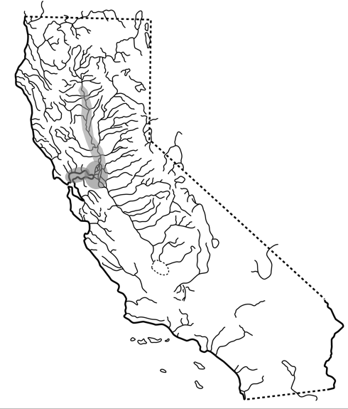

FIGURE X. Distribution of Sacramento splittail, Pogonichthys macrolepidotus (Ayres), in California.

